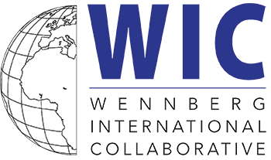

Poster Presentation Guidelines
2022 WIC Meeting, Luzern

Please include the following sections in your poster:

- Background
- Objectives
- Methods
- Results
- Discussion

Poster Size: These must be vertical (portrait) posters with one of the following dimensions:
- A1 Poster: 23.4 x 33.1 in / 59.4 cm x 84 cm
- Standard Medium Poster: 24 x 36 in / 60.9 x 91.4 cm

Font: For clarity use Times New Roman or Calibri fonts

Font Size: We strongly suggest:

the title: 64pt
headings: 48pt
body text 24pt
The smallest font size should be no less than 24-point.

Colors: Keep colors simple and legible, and only use color to highlight important elements

Please direct any questions to Jordan Taylor at Wennberg.Collaborative@dartmouth.edu

